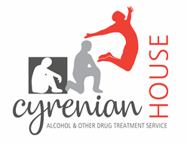
VOLUNTEER DRUG AND ALCOHOL COUNSELLORS’ TRAINING PROGRAM APPLICATION FORM - 2023

PLEASE NOTE
- This application is limited to 3 pages. Please ensure you adhere to this guideline.
- Due to the high number of applications received, feedback on unsuccessful applications unfortunately cannot be provided

First Name: |  |  |  |  | Surname:
Date of Birth:
Home Address:

Suburb: |  |  |  |  | Post Code:
Home Phone: |  |  |  |  | Mobile Phone:
Email:

- Overview of educational background:

- Overview of occupational background:

- Previous counselling experience, if any:

- Why are you interested in being a volunteer counsellor?

- What is your interest in the alcohol and drug field?

- Any other information you would like to include?

- How did you hear about the Cyrenian House Volunteer Program?

REFERENCES

Please supply the name and contact information of two referees.

Please email all completed applications to hr@cyrenianhouse.com

