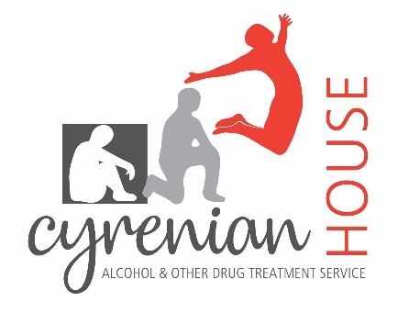

2023 Volunteer Drug and Alcohol Counsellors’ Training Program

Applications for this program will be available to download from the Cyrenian House website from March 3rd 2023. Applications will close on March 31st 2023.

http://www.cyrenianhouse.com

About the program:
Cyrenian House runs an annual Volunteer Drug and Alcohol Counsellors’ Training Program across all of its metropolitan based services. This program was established in 2012 using the Helping Change: the Drug and Alcohol Counsellors’ Training Package developed by Drug and Alcohol Office and the National Drug Research Institute, Curtin University of Technology.

There are two major components to the program:
1. An intensive training program comprising 20 four-hour workshops in both general and addiction counselling skills. Training sessions take place on Saturday morning from 9am to 1pm. Sessions cover general counselling skills including active listening, empathy, reflection of feelings, use of questions, supervision and confidentiality. Alcohol and other drug counselling skills include raising the issue of alcohol and other drug use, assessment, motivational interviewing, problem solving and goal setting, relapse and giving up.

2. A 12-month placement at one of Cyrenian’s treatment services (Perth, Warwick and Joondalup), in which volunteer counsellors provide a counselling service to agency clients. During this part of the program all counsellors are assigned to an experienced supervisor who is responsible for the management of their cases. Volunteers are required to complete a four-hour placement per week and will receive one hours' supervision twice a month.

People interested in applying to be a volunteer counsellor should possess
- a non-judgemental and open minded attitude towards drug use problems
- a knowledge of, an interest, or background in the alcohol and drug field
- a commitment to working with people with alcohol and other drug-related problems
- excellent interpersonal skills
- an ability to work with people from diverse backgrounds and different needs.

People who have experienced recent alcohol and other drug related problems (i.e. within the past two years) are not eligible to apply.

All applicants will be advised on the outcome of their application, however this may take up to one month following the application closing date. Unfortunately, due to the number of applications received, Cyrenian House is unable to provide feedback on unsuccessful written applications.

A shortlist of applicants will be invited for an interview that will be held in April 2023.

Aboriginal and Torres Strait Islanders applicants are strongly encouraged to apply.

Training for successful applicants will run from June to November 2023 and will be held at Cyrenian House’s Cyrenian Central site in Perth. Training runs on Saturdays from 9am to 1pm. Due to Covid, trainings may run online via Teams.

If you have any enquiries about the program, please contact:
Nicola Iannantuoni, General Manager Non-residential Services
Email: nicola.iannantuoni@cyrenianhouse.com or phone 0411 373 003

